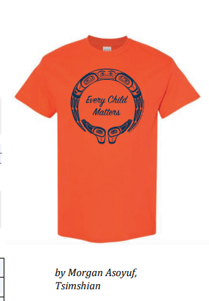
Orange Shirt Day is on Friday, September 30, 2022 to coincide with National Truth and Reconciliation Day. This year’s orange shirts are for sale in the main foyer beginning Tuesday, September 20th at lunch until shirts are sold out. $15, cash only featuring a unique design by Ts’msyen (Tsimshian) artist Morgan Asoyuf. The design this year reflects the love and respect we hold for every child and the multi-generational impact of Residential Schools and the resilience of those who have survived. All proceeds are directed to the Native Northwest Reconciliation Fund to support those who continue to suffer intergenerational trauma.
Please support this initiative by wearing your orange shirt with thoughtfulness and awareness, especially on Thursday, September 29, 2022 when Gleneagle students and staff will be recognizing the importance of National Truth and Reconciliation. Be intentional and learn more about this statutory holiday by starting here: National Day for Truth and Reconciliation - Canada.ca
You may recall that the “orange shirt” in Orange Shirt Day refers to the new shirt that Phyllis Webstad was given to her by her grandmother for her first day of school at St. Joseph’s Mission residential school in British Columbia. When Phyllis got to school, they took away her clothes, including her new shirt. It was never returned. What is Orange Shirt Day? | Articles | CBC Kids
To Phyllis, the colour orange has always reminded her of her experiences at residential school and, as she has said, “how my feelings didn’t matter, how no one cared and I felt like I was worth nothing. All of us little children were crying and no one cared.”
Did you know that we have an Indigenous Youth Worker here on Tuesdays/Fridays: Steph Watson who is Cree, has an office by Room 210.

